Blue Walkthrough

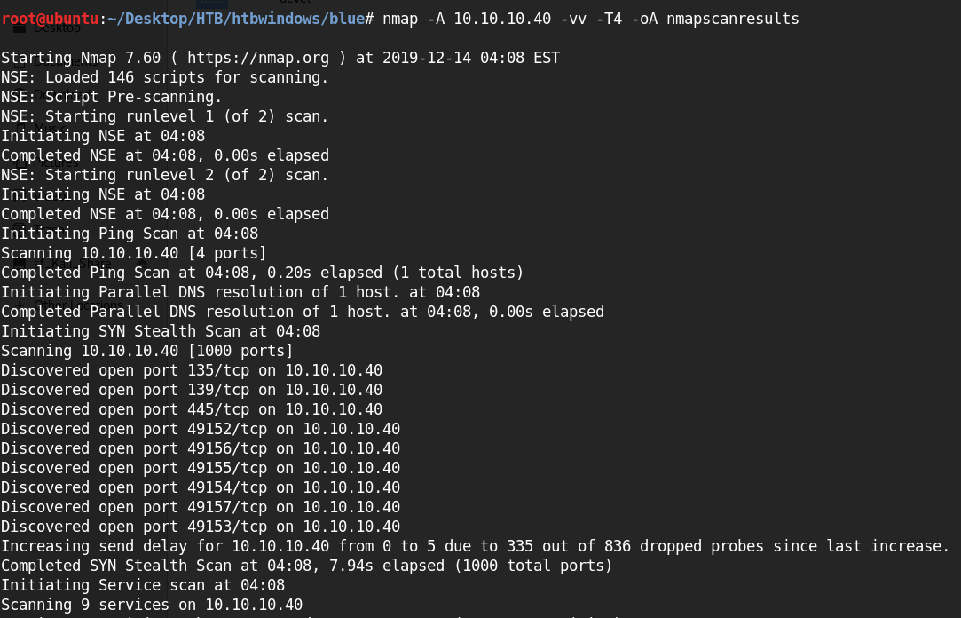

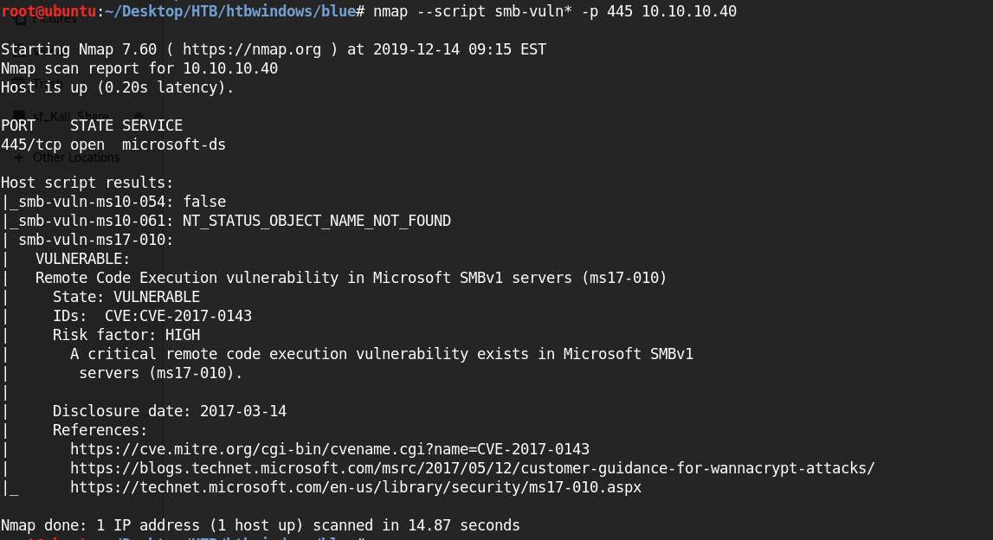

<https://root4loot.com/post/eternalblue_manual_exploit/>

